1. Free Assets for Everyone

<https://www.gameart2d.com/freebies.html>

<https://gameartpartners.com/downloads/totally-free-goodies/>

<https://www.glitchthegame.com/>

https://www.gamedevmarket.net/

https://opengameart.org/

<https://spritedatabase.net/>

https://www.supergameasset.com/

1. Game Loop

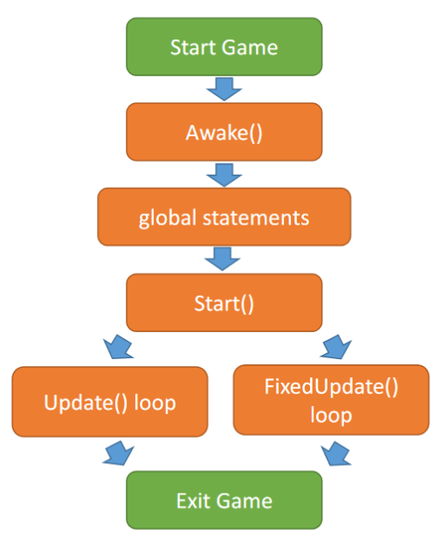

1. Script lifecycle

<https://docs.unity3d.com/Manual/ExecutionOrder.html>

1. Các lớp cần lưu ý trong UnityEngine

* GameObject
* MonoBehaviour
* Input
* Transform
* Vector3/Vector2

1. Simple Example

*Di chuyển, xoay nhân vật simple dùng Transform*

using System.Collections;

using System.Collections.Generic;

using UnityEngine;

public class Player : MonoBehaviour

{

public float moveSpeed = 5f;

public Vector3 moveInput;

// Start is called before the first frame update

void Start()

{

}

// Update is called once per frame

void Update()

{

moveInput.x = Input.GetAxis("Horizontal");

moveInput.y = Input.GetAxis("Vertical");

transform.position += moveInput\*moveSpeed \*Time.deltaTime;

if(moveInput.x !=0)

{

if(moveInput.x >0)

{

transform.localScale = new Vector3(1, 1, 0);

}

else

{

transform.localScale = new Vector3(-1, 1, 0);

}

}

}

}